A Spring Visit to Bear Spring Camps, Maine

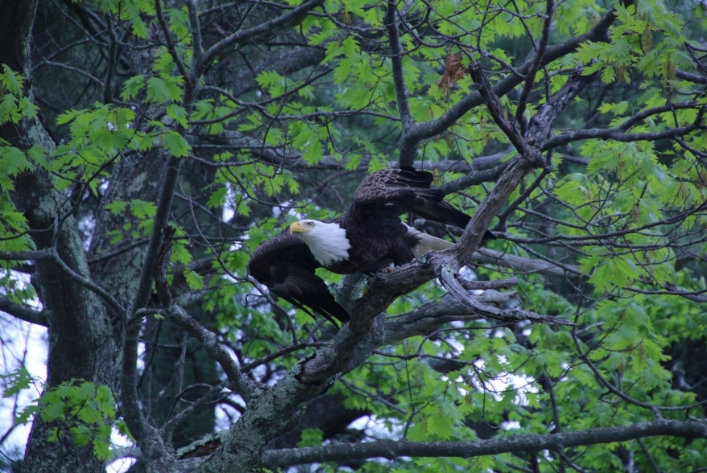May brought us another fine trip to the Belgrade Lakes in Maine. Being one of our favorite vacation spots, we spent the week in our usual cabin by Great Pond. So, what’s there? Well, Peg and Ron Churchill provide us a full-featured Internet-free lakeside cabin with a working wood stove with firewood replenished and three excellent meals daily, and all the kayaking, fishing, photography opportunities, hiking, and leisure activities which appeal to us.

In the photo album below, check out:

* The variety of wildlife
* The eagles
* The banded eagle
* The serene kayaking waters
* The nesting loon

And for the photos, click [Bear Spring -2017](https://goo.gl/photos/Fwk1HDtZnASyuZxY7).